Computer Breakdown Service
As the teacher is breaking down a computer, take note of how each of the pieces, or components, of the computer work together and its function – what it is used for and why it is needed. Some components aren’t physically inside the computer, so are external.
Component | Function
Keyboard
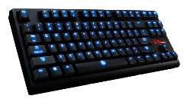
Mouse
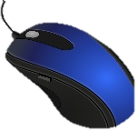
Hard Disk Drive
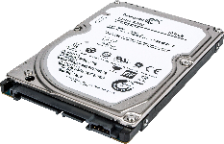
CPU
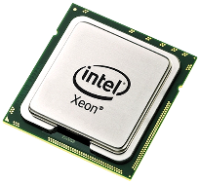
RAM
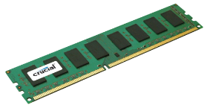
Power Supply
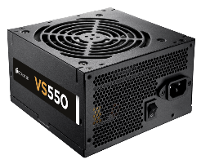
Graphics Card
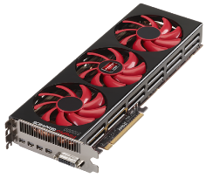
Web Cam

Microphone
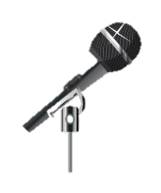
Monitor

Motherboard
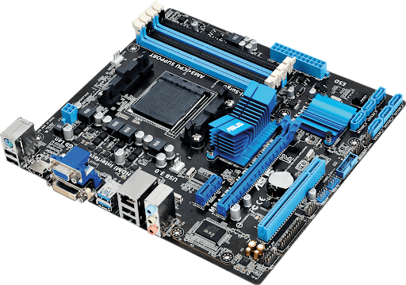
Fan Unit/Heat sink
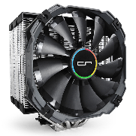
Chassis


In the space below, write something that you learnt today:

